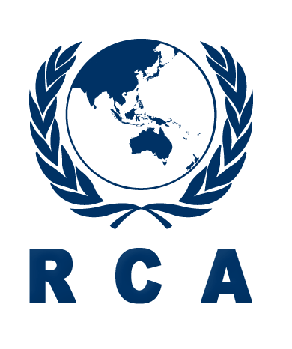

2016 RCARO Managed Project
Introductory Workshop for New RCA Government Parties on
RCA Programme and its Policy

Coral Coast, Fiji, 23-25 November 2016

PROVISIONAL PROGRAMME

Day 1 – Wednesday, 23 Nov. 2016
09:30 |  | Registration
10:00 |  | Opening (Chair: RCARO)  - Opening Remarks (by Mr Hai-Joo Moon, DIR-RCARO)  - Opening Remarks (by Dr. Lusiana Boseiwaqa, Acting Medical Superintendent Lautoka Hospital, Ministry of Health and Medical Services, Fiji)  - Welcoming Remarks (by Mr Olusegun O. Ajibulu, NR of FIJI)  - Congratulatory Remarks (by Mr. Sinh Hoang, RCA Focal Person, IAEA)  - Self-introduction of the participants  - Designation of rapporteur  - Adoption of the agenda
11:00 |  | Group Photo / Coffee Break
11:30 |  | Introduction to the Workshop (by RCARO)
12:00 |  | Lunch Break
Session I |  | Overview of the IAEA Technical Cooperation Programme (Chair: Mr Engr. Md. Monzurul Haque, Immediate Next RCA Chair and NR of Bangladesh)
14:00 |  | Overview of the IAEA  - TC Department and Strategy  - Management of RCA Projects (Role of IAEA under RCA Agreement)
14:40 |  | Overview of TC Programme and TC Projects  - Planning, Implementation, Monitoring, Reporting, Final Assessment and Closure  - Overview of TC IT Tools (PCMF, InTouch, TC Pride)
15:20 |  | Coffee Break
15:50 |  | Discussion
Session II |  | Overview of the RCA Programme and RCA Regional Office (Chair: Mr. Ishtiaq Hussain Bokhari, Immediate Past RCA Chair and NR of Pakistan)
16:20 |  | Overview of RCA I
16:20 |  | - RCA Agreement and RCA Guideline and Operating Rules (by Mr. Peter McGlinn, AUL)
16:50 |  | - RCA MTS 2018-2023 and its Working Groups (by Mr. Christopher Daughney, NR of NZE)
17:10 |  | Overview of RCA II (by Mr. Mavag Chadraabal, RCA Chair and NR of MON)  - Decision Making Procedures in the RCA Programme  - Roles and Responsibilities of National RCA Representatives to the RCA
17:30 |  | Discussion
18:00 |  | End of Day 1
18:30 |  | Dinner hosted by RCARO
Day 2 – Thursday, 24 Nov. 2016
Session II | Overview of the RCA Programme and RCA Regional Office (Continued)
9:30 | Implementation of RCA Projects (Mr John Easey, Chair of RCA PAC)  - Project cycle and planning  - Roles/responsibilities of NRs and LCC/NPCs  - RCA PAC and its activities
10:15 | Discussion
10:45 | Coffee Break
11:15 | Operation and Management of RCARO (by RCARO)  - Introduction to RCARO and its Activities  - Provisional Yearly Timeframe of 2017
12:00 | Discussion
12:30 | Lunch Break
Session III | Discussion on the Future Projects/Programmes for the New RCA GPs (Chair: Ms. Soledad Castaneda, NR of PHI)
14:00 | Country Reports by New RCA GPs (20min per GP including discussion. Presentations will include Nuclear Status, Needs, National Development Strategy/Priorities/Plan, and International Cooperation in Nuclear Field)  - Country Report of Cambodia (by NR of KAM)  - Country Report of Fiji (by NR of FIJ)  - Country Report of Laos (by NR of LAO)  - Country Report of Nepal (by NR of NEP)  - Country Report of Palau (by NR of PLW)
15:40 | Coffee Break
16:10 | Possible Projects/Programmes for the New RCA GPs (by Mr Chris Daughney, NR of NZE)
16:30 | Discussion
18:00 | End of Day 2
Day 3 – Friday, 25 Nov. 2016
Session IV | Closing
09:00 | Presentations by Pacific Island Development Forum (PIDF) and South Pacific Commission (SPC)
09:30 | Wrap-up Discussions  - Refinement of Conclusions and Recommendations  - Review of Draft Workshop Report
12:00 | Lunch
13:30 | Technical Tour

