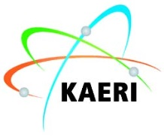
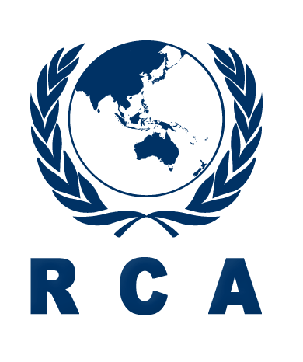
2020 RCA/KAERI Introductory Training Course on
Radiation Technology and its Applications

PROSPECTUS

Title : | 2020 RCA/KAERI Introductory Training Course on Radiation Technology and its Applications
Place : | Korea Atomic Energy Research Institute (KAERI), Daejeon, Republic of Korea
Date : | May 11- May 22, 2020
Deadline for  Nominations : | March 13, 2020
Organizers : | RCA Regional Office (RCARO) in cooperation with Korea Atomic Energy Research Institute (KAERI)
Course Organizers : | Mr. JinKyu LIM  Head, Administration  RCA Regional Office  Tel: +82 42 868 4905  E-mail: jklim@rcaro.org  Mr. Moon-Sung Cho  Nuclear Training & Education Center  Korea Atomic Energy Research Institute  Tel: +82 42 868 2581  E-mail: mscho1@kaeri.re.kr
Language: | The language of instruction will be English
Participation: | This training course is open to 15-20 participants from RCA Government Parties.  Each Government Party will be able to nominate up to one or two candidates.
Target Countries: | Bangladesh, Cambodia, China, Fiji, India, Indonesia, Laos, Malaysia, Mongolia, Myanmar, Nepal, Pakistan, Philippines, Palau, Sri Lanka, Thailand, Vietnam
Purpose of the  Course: | The purpose of the training course is to introduce the technical and practical knowledge on radiation technology and its applications
Scope: | The training course will include lectures by recognized experts from related institutes in Korea in the areas of radiation policy & safety, research reactor technology, and radiation applications in agriculture, food, human health, industry and medicine.  The training course will also be a benchmarking opportunity, providing a forum for the participants to discuss their national practices and to exchange their experience related to the subjects covered. Participants are requested to prepare and submit their country report individually or as a group via e-mail (mscho1@kaeri.re.kr) until April 20, 2020. The Participants will be required to deliver a presentation of their action plan to implement the acquired knowledge at the end of the course.
Participants’ qualifications and experience : | Participants should be technical or managerial professionals directly involved in the field of radiation application technology in government authorities, R&D institutes, and regulatory bodies with less than 5 years of relevant experience in the field. Bachelor’s degree or equivalent experience is required.  Participants should have sufficient proficiency in English to follow lectures without difficulty.
Application Procedure : | Completed application forms should be endorsed and approved by the National RCA Representatives and be received at the below address no later than March 13, 2020.  RCARO  Tel: +82 42 868 8224  Fax: 82 42 864 1626  E-mail: rcaapply@rcaro.org  Nominations received after this date or applications which have not been endorsed by the National RCA Representatives cannot be considered.
Administrative and Financial  Arrangements: | During the training course, RCARO will provide the participants with a stipend sufficient to cover the cost of their accommodation, food and minor incidental expenses. RCARO will also provide the participants with a round-trip air ticket, economy class, from their home countries to Incheon, Korea and return.  Participants will be provided with standard travel insurance. However, the organizers of the training course do not accept liability for the payment of any cost or compensation that may arise from damage to or loss of personal property, or from illness, injury, disability or death of a participant while he/she is travelling to and from or attending the training course and it is clearly understood that each Government, in nominating participants, undertakes responsibility for such coverage. Governments would be well advised to take out insurance against these risks.

2020 RCA/KAERI Introductory Training Course on
Radiation Technology and its Applications
Daejeon, Korea
May 11 – May 22, 2020

1 | Introduction
 | 1.1 | Introduction to RCARO
 | 1.2 | Status of Radiation Industries in Korea
2 | Radiation Policy & Safety
 | 2.1 | Nuclear Radiation Application Policy in Korea
 | 2.2 | International and National Framework for Radiation Protection and Safety
 | 2.3 | Regulatory Control
 | 2.4 | Radiation Protection in Radiation Installations
3 | Research Reactor Technology
 | 3.1 | Overview of Research reactor ‘HANARO’
 | 3.2 | Radioisotope Production and application
 | 3.3 | Neutron Instrument Development
 | 3.4 | Neutron Beam Application
4 | Radiation Technology and its Applications
 | 4.1 | Sealed Source Production
 | 4.2 | Radiation Technology Application for Agriculture
 | 4.3 | Food Irradiation
 | 4.4 | Drug Evaluation using Radioisotope
 | 4.5 | Cyclotron and its Application
 | 4.6 | Radiation for Advanced Materials
 | 4.7 | Non-Destructive Testing
5 | Action Plan, Country Report
 | 5.1 | Action Plan and Presentation
 | 5.2 | Country Reports and Discussion
6 | Other Activities (Technical Tour, Culture Tour)
Technical Tour: HANARO, RI production Fac., Cyclotron center, Co-60, RI-biomics center, Radiation Breeding center, NTC Lab.
Culture Tour: Namsan Mt., Jeonju Hanok Village
※ The above curriculum is subject to change depending on the circumstances.

